Name: Project: Linear Modeling (PQL)
Mat 115:Prof. Rudy Meangru
Project #1: ( / 30 pts) 2- week period

[ Dear student you may consult with other students for help, but under no circumstances take someonelse work and claim it to be yours]

In this activity you will be investigating the rising cost of the MTA transit fare over a period of time in New York City. The goal is to use data to develop a simple mathematical model which can be used to make some reasonable predictions.

You will incorporate the use of algebraic skills such as graphing, rate of change and linear function to complete this activity.

Step 1: Introduction ( 2pts)

Read through this activity and then write a brief introduction of the goals in this activity.

Step 2: Scatter Plot ( 5pts)

Use the following data provided in the table below to obtain a scatter plot of time vs. price. Describe the trend of the price in the plot. Do you find the trend shocking?

Time Line | Price(dollars)
1970 | $0.20
1980 | $0.50
2003 | $2.00
2009 | $2.25
2013 | $2.50
2015 | $2.75

Step 3: Defining your variables.(2 pts)

Identify your independent and dependent variables using appropriate symbols to state them.

Let the independent variable ?? represents the time in years and the dependent variable ?? represents the cost in dollars.

Step 4: Average rate of Change (4 pts)

Compute the average rate of change per year of the cost over each time period.

Just fill in the result; don’t’ show the calculation.

Time Line | Price(dollars) | Average rate of change
1970 | $0.20 | XXXXXXXXXXXXX
1980 | $0.50
2003 | $2.00
2009 | $2.25
2013 | $2.50
2015 | $2.75

Do these values suggest a linear trend? Explain.

Step 5: Linear Modeling (6 pts)

Assuming that the trend is linear, generate a linear model.
To make the calculation easier, rescale the time values for 2009 through 2015 in the above table.

Let 2009 be the year 0.

t | P( dollars)
0

Using any two data points from the rescaled table develop a possible linear model of the above data by filling in the blanks in the following calculation.

(0, 2. 25) and ( , )

P = at + b P = at + ?
a = ( - )/( - )

a = /

a =

P = ?t + ?

Predict the price in 2020

For 208, t = ? P = ?( ? ) + ? P =

According to this model, the Price is expected to be about $ in the year 2018.

Step 6: Using EXCEL (6 pts)

- Obtain a scatter plot of the data with the “best-fit” line.

- Generate the linear model through EXCEL.

- Using this model predict the price in 2018.

- Using this model predict the price in 2018?

Step 7: Reflection ( 5 pts)

What have you learned from this activity? What challenges did you face and how did you overcome them? What mathematical skills and knowledge did you use to complete this assignment? Did you need to look back at any prior mathematical skills? Did you seek assistance from anyone and was it helpful? Compare the predictions that you get from the two models? Is your computed value a reasonable one to what the fare is currently? What are some of the pitfalls with this linear modeling procedure? Has this activity help you to better appreciate mathematics?
How has this change your feeling about mathematics?

See addendum for EXCEL instruction.

EXCEL INSTRUCTION

Let’s use the table below as a sample to obtain the desired out from EXCEL.

Day | Expense
1 | 30.80
2 | 25.55
3 | 26.35
4 | 28.30
5 | 30.50
6 | 50.50
7 | 60.80

Step 1: Access Excel spreadsheet.
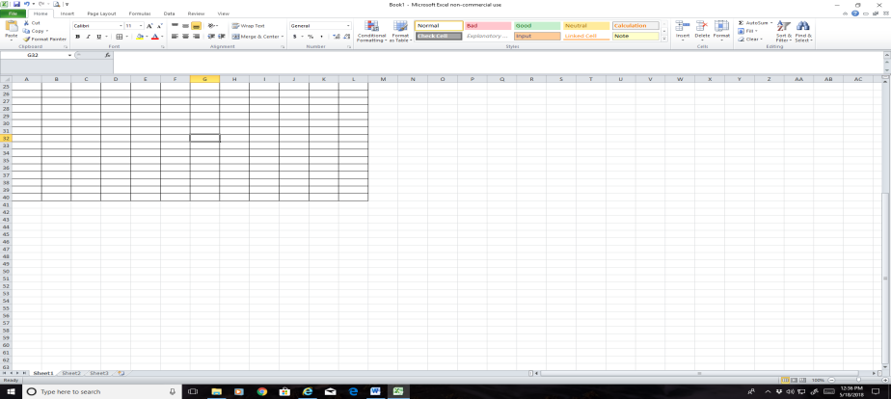

Step 2: Enter the data set either my typing it in EXCEL or copy from the word file and paste it into EXCEL.
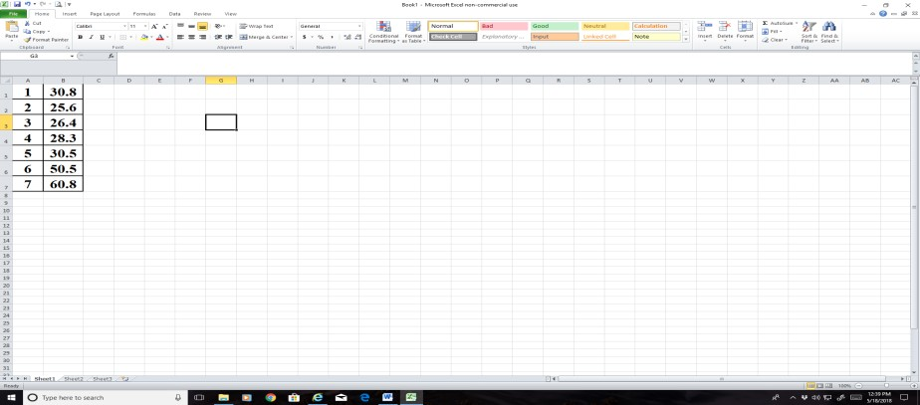

Step 3: To obtain a scatterplot, highlight the data set, select “Insert” on the menu bar and then “Scatter” .

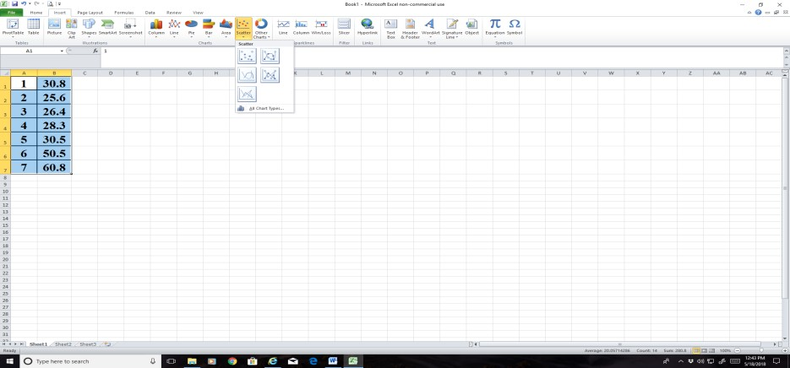

Step 4: Make a choice to obatin the scatter plot.
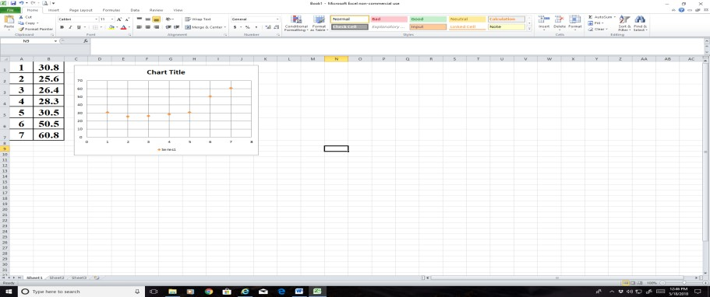

Step 5: To obtain a regression line or curve, place your cursor on any dot and right click. A pull-down menu appears. Select “ Add Threadline” and choose the required model anlong with “ Display Equation on chart”
